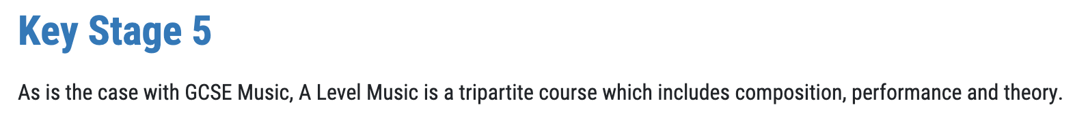

Please can ‘theory’ be replaced with appraising music?

Intent (replacement)

Music at Holland Park School is an inclusive subject that is designed to allow all learners to develop a love of music and fulfil their musical potential through inspiring and engaging experiences. We wish to empower students with special educational needs and disabilities to access all musical opportunities at the school, providing support where needed, celebrating their strengths and differences, and setting them up for success in adulthood: https://www.hollandparkschool.co.uk/life-at-holland-park/send
Music as an art form is an important part of cultural identity, and it offers our students a creative output of expression in a language that is recognised universally. The music curriculum is coherently planned and sequenced, developing students’ skills in listening, performance, composition, singing and music technology across a range of historical periods, genres, styles and traditions. We prepare our students for lifelong musical learning and appreciation for the subject, both in and out of school, including an understanding of progression routes and careers in the wider music profession.

Homework in Music

Homework for KS3 and KS4 is set centrally on Teams. All homework is set on a Monday and they are due on the first lesson of the following week. Homework for KS5 is set by the classroom teacher.

KS3 students will be set 30-minute assignments once every fortnight on Teams. They will include online listening quizzes on Microsoft Forms, memorisation of key vocabulary (offline) and practical learning, e.g., singing.

KS4 – students will be set 1-hour assignments every week on Teams. They will include: a) online listening quizzes on the platform ‘Elemental’; b) further reading (offline); c) memorisation of factual knowledge related to each area of study; d) memorisation of key vocabulary; e) extended writing tasks, and f) practical learning on a musical instrument.

KS5 – students will be set 1-hour assignments every lesson on Teams. They will include: a) online listening quizzes on the platform ‘Elemental’; b) further reading (offline); c) memorisation of factual knowledge related to each area of study; d) memorisation of key vocabulary; e) extended writing tasks, and f) practical learning on a musical instrument.

